

Student Name……………………………………

MATHEMATICAL METHODS (CAS) UNITS 3 & 4

TRIAL EXAMINATION 1

2008

Reading Time: 15 minutes
Writing time: 1 hour

Instructions to students
This exam consists of 12 questions.
All questions should be answered in the spaces provided.
There is a total of 40 marks available.
The marks allocated to each of the questions are indicated throughout.
Students may not bring any calculators or notes into the exam.
Where an exact answer is required a decimal approximation will not be accepted.
Where more than one mark is allocated to a question, appropriate working must be shown.
Diagrams in this trial exam are not drawn to scale.
A formula sheet can be found on page 13 of this exam.

This paper has been prepared independently of the Victorian Curriculum and Assessment Authority to provide additional exam preparation for students. Although references have been reproduced with permission of the Victorian Curriculum and Assessment Authority, the publication is in no way connected with or endorsed by the Victorian Curriculum and Assessment Authority.

© THE HEFFERNAN GROUP 2008
This Trial Exam is licensed on a non transferable basis to the purchasing school. It may be copied by the school which has purchased it. This license does not permit distribution or copying of this Trial Exam by any other party.
Question 1

Let 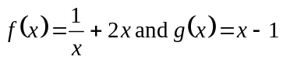.
Write down the rule for 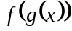.

1 mark

Question 2

Solve the following equations for x.

- 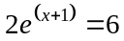.

1 mark

- 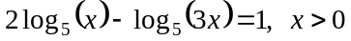

2 marks

Question 3

- Let 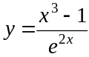.

Find 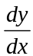.

1 mark

- If 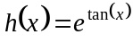 then evaluate 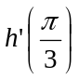.

2 marks

Question 4

The graph of 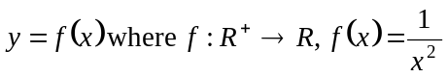 is shown below.

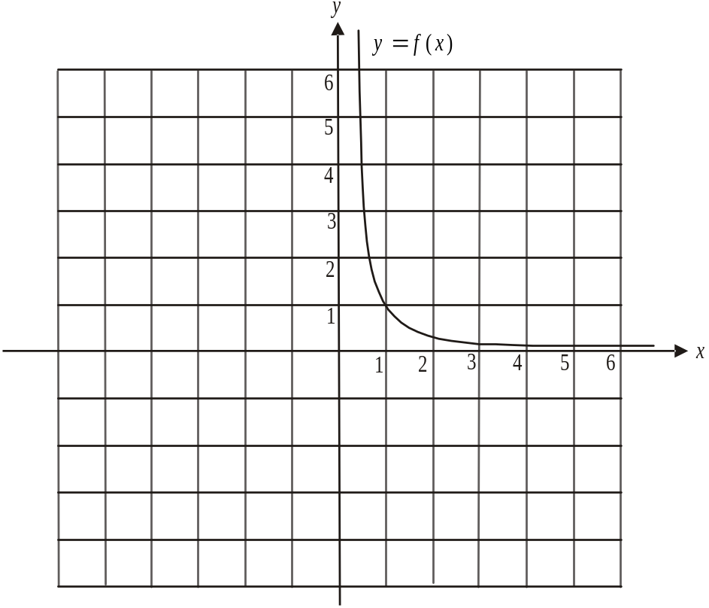

a. This graph of 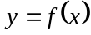 is dilated by a factor of 2 units from the y-axis to become the graph of the function g.

i. On the same set of axes as the graph of above, sketch the graph of 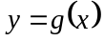 labelling clearly two points that lie on the graph.

  - Write down the rule for g.

Question 4 continues on the next page.
Question 4 (continued)

The graph of is shown again below.

b. The graph of 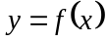 is translated one unit to the right to become the graph of the function h.

i. On the same set of axes as the graph of above, sketch the graph of 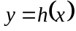 labelling clearly two points that lie on the graph.

ii. Write down the equation of the vertical asymptote of the graph of .

______________________________________________________________

iii. Write down the equation of the horizontal asymptote of the graph of .

iv. Write down the rule for h.

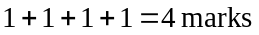

Question 5

In the past, ten percent of people who have been offered a scholarship to complete a particular tertiary course have been male. Of the three scholarships offered this year, what is the probability that less than two were offered to females?

2 marks

Question 6

The winnings; X, in dollars, from a game is a discrete random variable.
The probability distribution for X is given in the table below.

X | 0 | 1 | 2 | 5 | 10
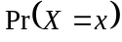 | 0.1 | a | 0.4 | b | 0.2

- Given that 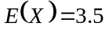, explain why 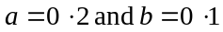.

2 marks

- What is the median of X ?

1 mark

- If two people who are playing the game are selected at random, what is the probability that they win the same amount?

1 mark

Question 7

Consider the function 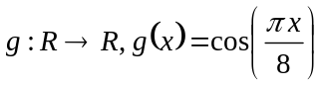.

- Find the solution(s) to the equation 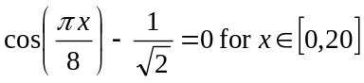.

2 marks

Consider the function 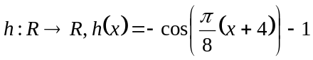.

- Find the value(s) of x for which 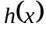 is a minimum for 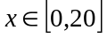.

2 marks

Question 8

Find the equation of the tangent to the graph of 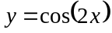 at the point where 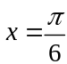.

2 marks

Question 9

- Find the derivative of 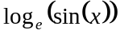.

1 mark

- Hence evaluate 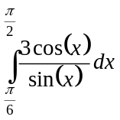.

2 marks
Question 10

The graphs of the functions
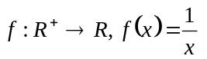

and 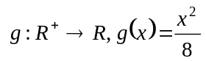

are shown below.
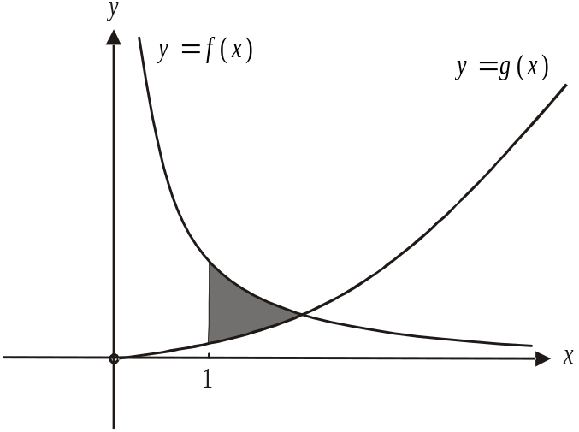

The region enclosed by the graphs of 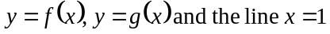 is shaded in the diagram. Find the area of this shaded region.

4 marks
Question 11

Harry plays football each Saturday.

The probability that Harry plays well given that he slept well the previous night is 0.6.
The probability that Harry plays well given that he didn’t sleep well the previous night is 0.5.

The probability that Harry sleeps well on a Friday night is 0.3.

- What is the probability that on a certain Saturday Harry plays well?

2 marks

- What is the probability that Harry has slept well on a particular Friday night given that Harry has not played well the following Saturday?

2 marks

Question 12

The graphs of the functions
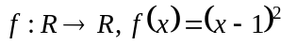

and 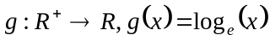

are shown below.
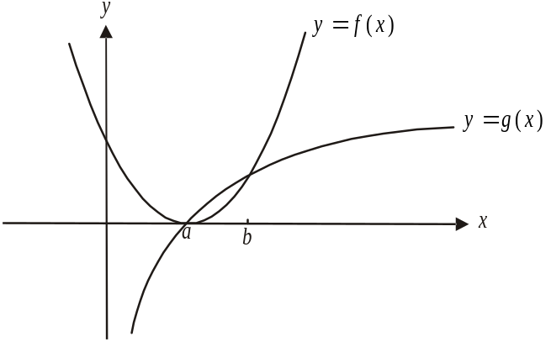

The graphs intersect at the points where 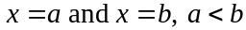.

- Show that .

1 mark

- Find the value of x for which the difference between the value of f and the value of g is a maximum for 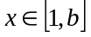.

3 marks

Mathematical Methods and Mathematical Methods CAS Formulas

Mensuration

area of a trapezium: 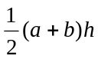 volume of a pyramid: 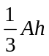
curved surface area of a cylinder: 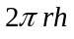 volume of a sphere: 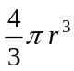
volume of a cylinder: 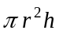 area of a triangle: 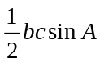
volume of a cone: 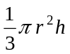

Calculus
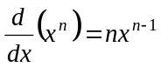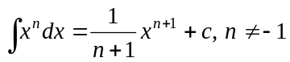
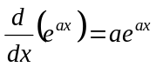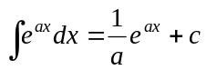
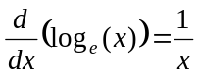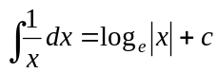
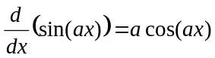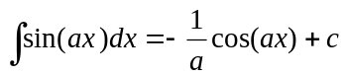
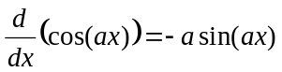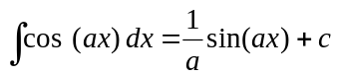
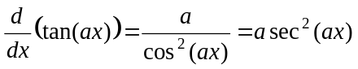
product rule: 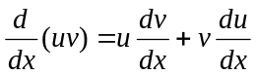 quotient rule: 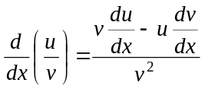
chain rule: 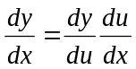 approximation: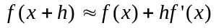

Probability
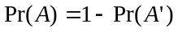
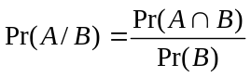
mean: 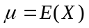 variance:

probability distribution |  | mean | variance
discrete | 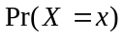=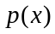 | 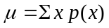 | 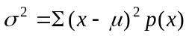
continuous | 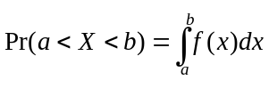 | 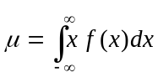 | 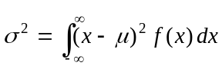

Reproduced with permission of the Victorian Curriculum and Assessment Authority, Victoria, Australia.
This formula sheet has been copied in 2008 from the VCAA website www.vcaa.vic.edu.au
The VCAA publish an exam issue supplement to the VCAA bulletin.

